Shubham Shekhaliya

U18CO018

Assignment-3(MIT)

1-> Store the data byte 32H into memory location 4000H.

Code:-

MVI A, 32H

STA 4000H

HLT

Output:-

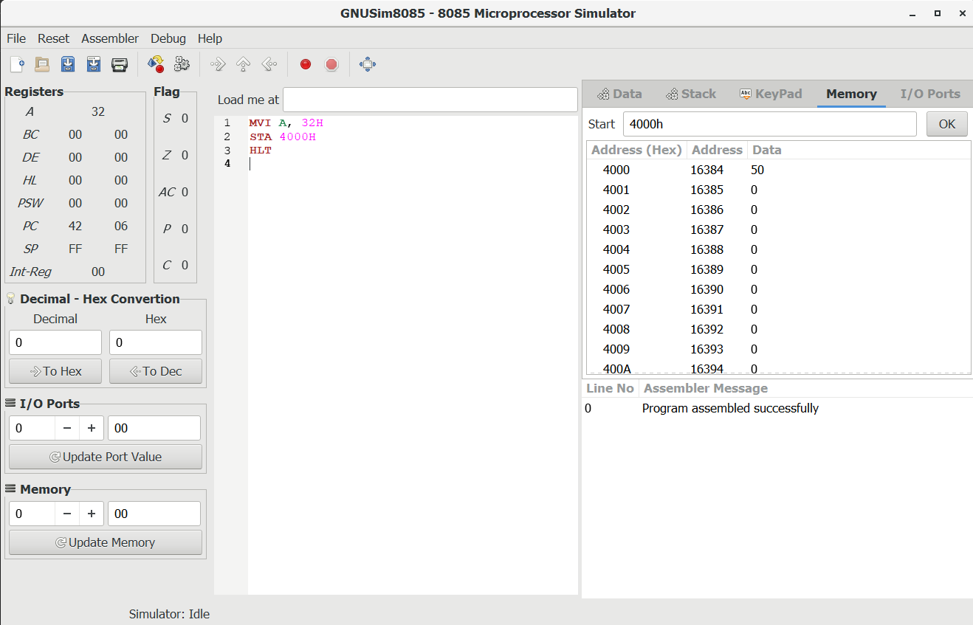

2-> Exchange the contents of memory locations 2000H and 4000H.

Code:-

LDA 2000H

MOV B,A

LDA 4000H

STA 2000H

MOV A,B

STA 4000H

HLT

Output:-

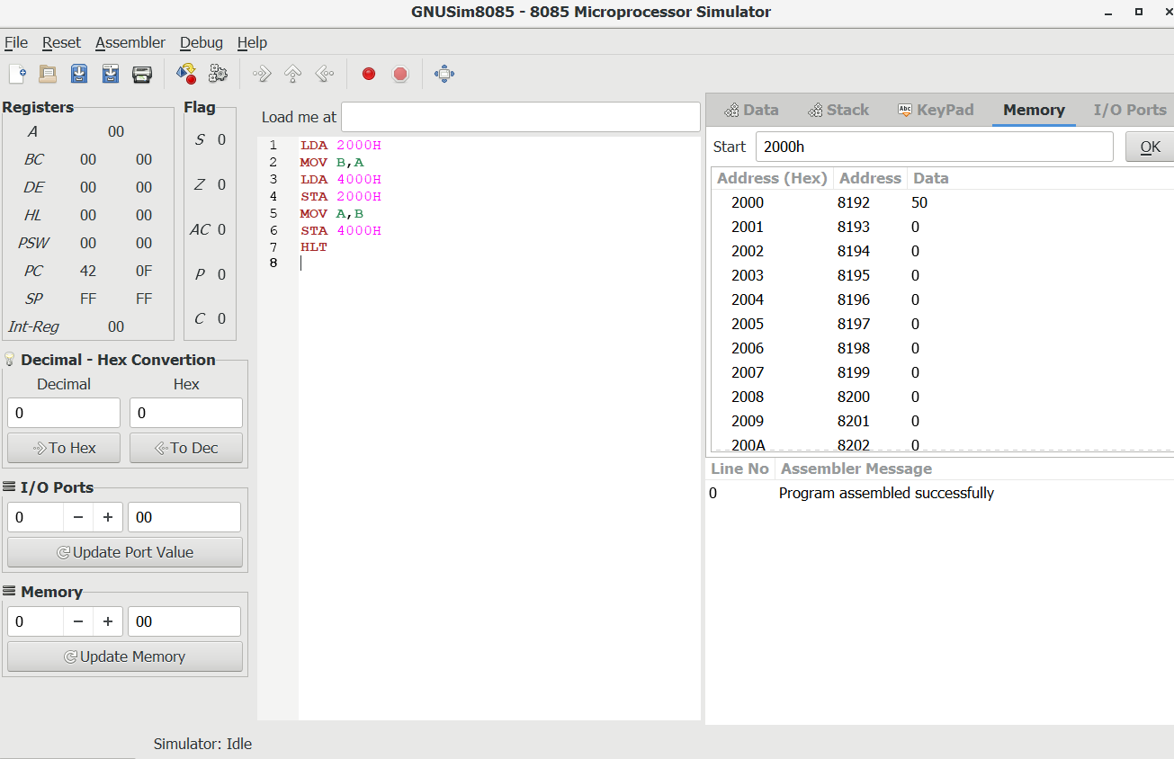

3-> Add two 8-bit numbers: Add the contents of memory locations 4000H and 4001H and place the result in memory location 4002H.

Code:-

MVI A,12H

STA 4000H

MVI A,32H

STA 4001H

LXI H, 4000H

MOV A, M

INX H

ADD M

INX H

MOV M,A

HLT

Output:-

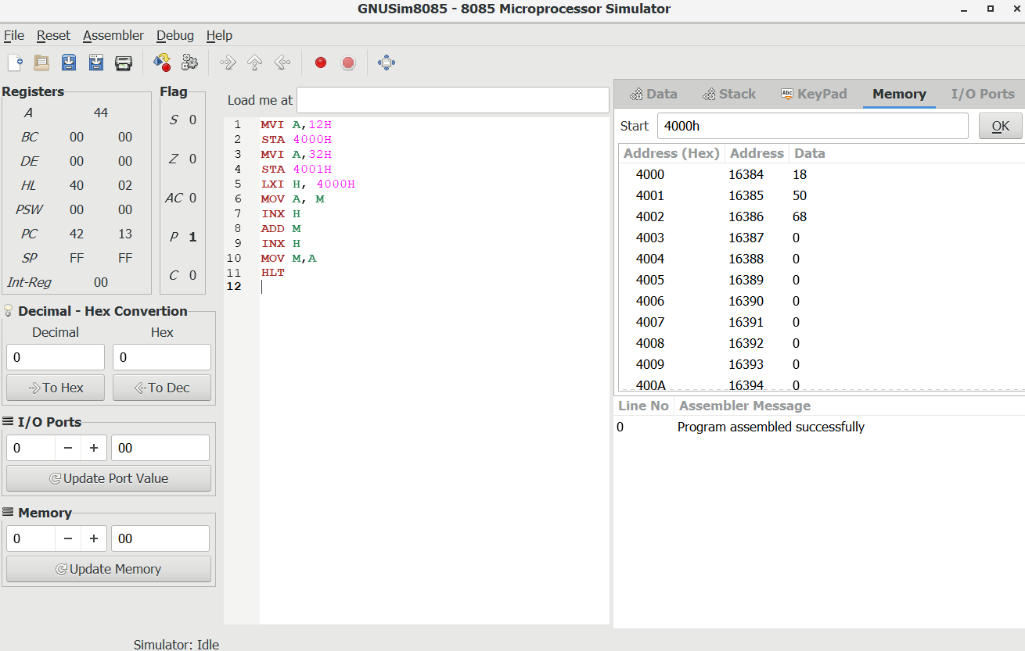

4-> Subtract two 8-bit numbers: Subtract the contents of memory location 4001H from the memory location 2000H and place the result in memory location 4002H.

Code:-

MVI A,32H

STA 4000H

MVI A,12H

STA 4001H

LXI H,4000H

MOV A,M

INX H

SUB M

INX H

MOV M,A

HLT

Output:-

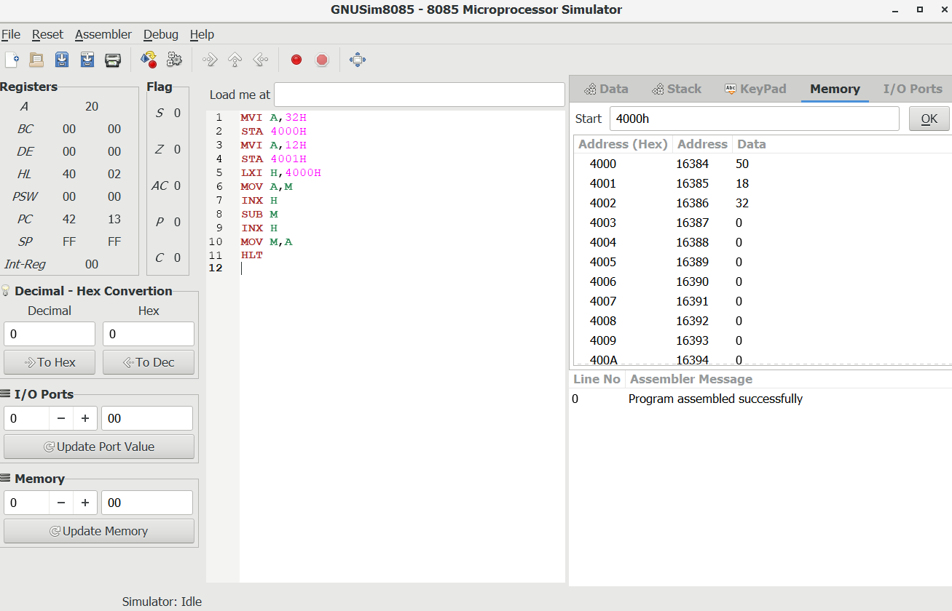

5-> Add the 16-bit number in memory locations 4000H and 4001H to the 16-bit number in memory locations 4002H and 4003H. The most significant eight bits of the two numbers to be added are in memory locations 4001H and 4003H. Store the result in memory locations 4004H and 4005H with the most significant byte in memory location 4005H.

Code:-

MVI A,12H

STA 4000H

MVI A,32H

STA 4001H

LHLD 4000H

XCHG

LHLD 4002H

MOV A, E

ADD L

MOV L, A

MOV A, D

ADC H

MOV H, A

SHLD 4004H

HLT

Output:-

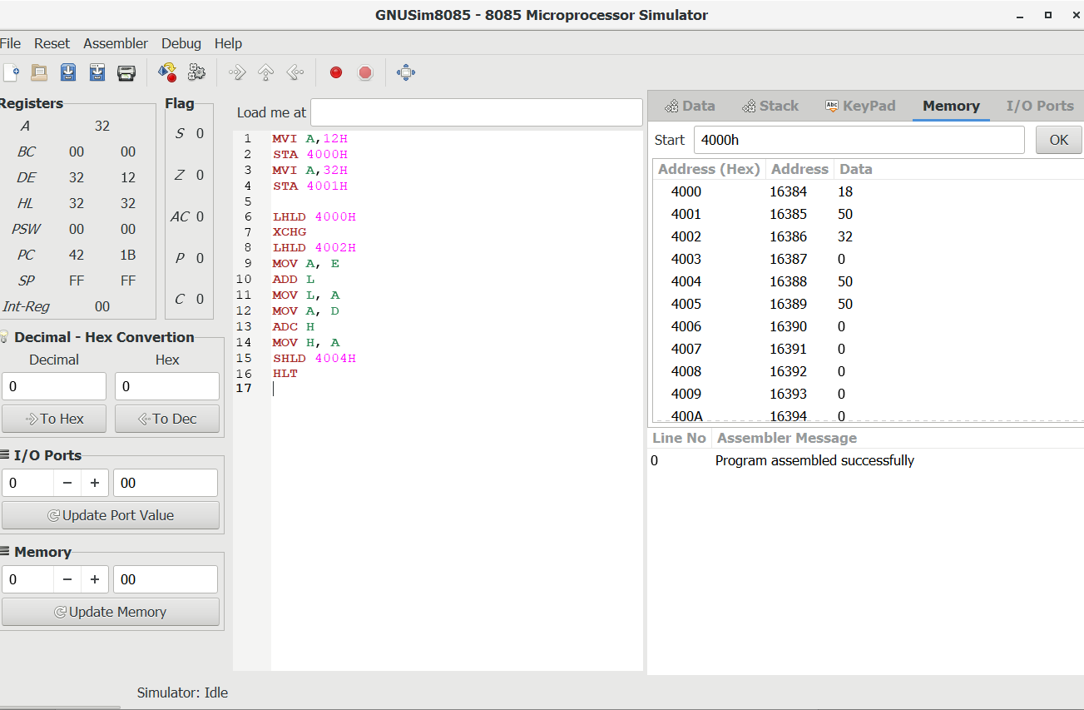

6-> Add contents of two memory locations: Add the contents of memory locations 4000H and 4001H and place the result in the memory locations 4002H and 4003H.

Code:-

LXI H,4000H

MOV A,M

INX H

ADD M

INX H

MOV M, A

MVI A, 00H

ADC A

INX H

MOV M,A

HLT

Output:-

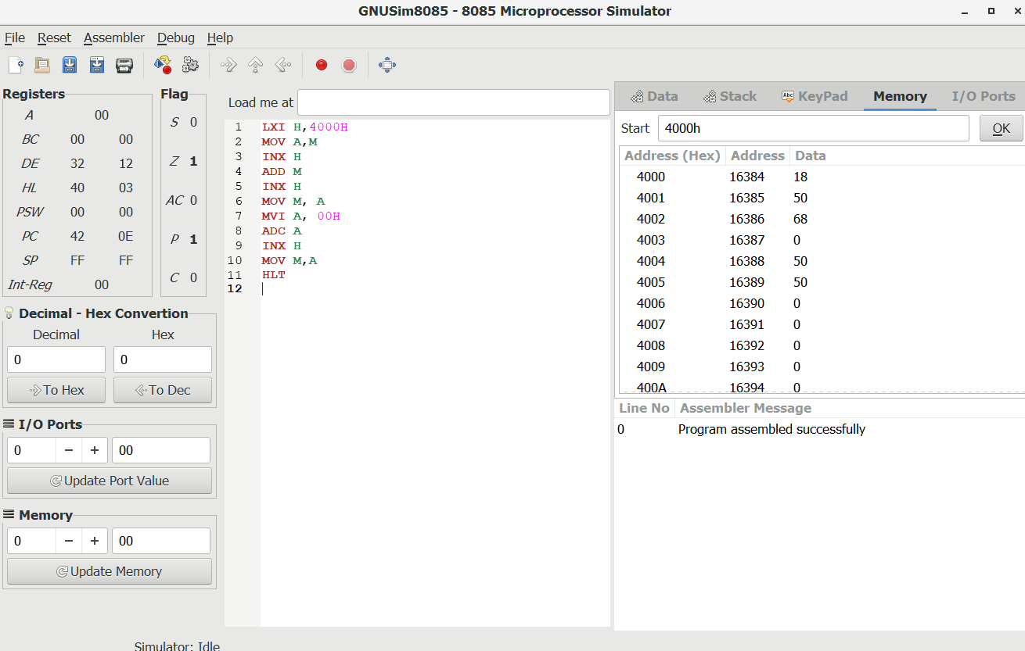

7-> Write a program for one’s complement of 8 bit number.

Code:-

LDA 4000H

CMA

STA 4001H

HLT

Output:-

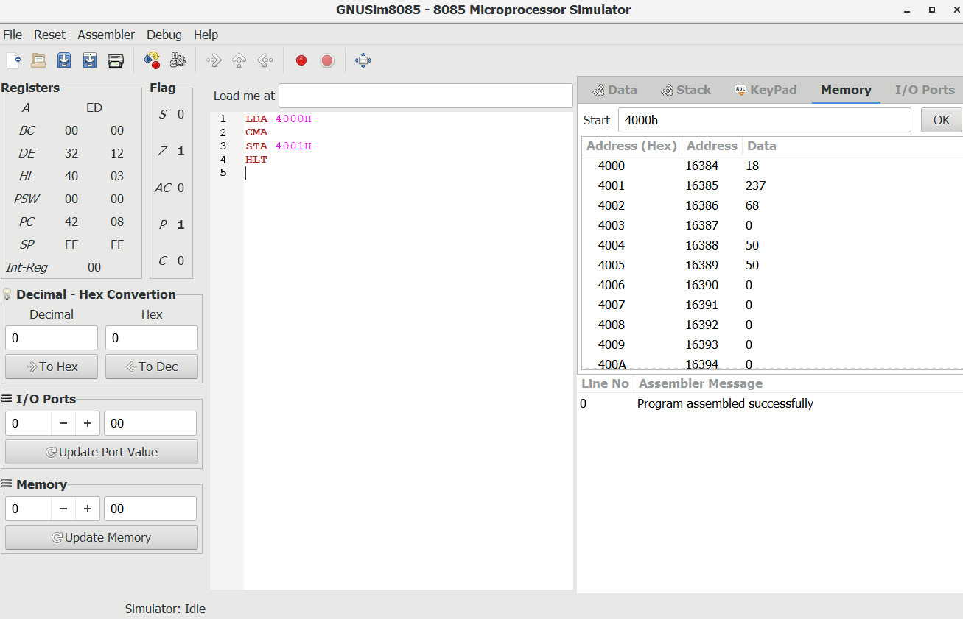

8-> Write a program for two’s complement of 8 bit number.

Code:-

LDA 4000H

CMA

ADI 01H

STA 4001H

HLT

Output:-

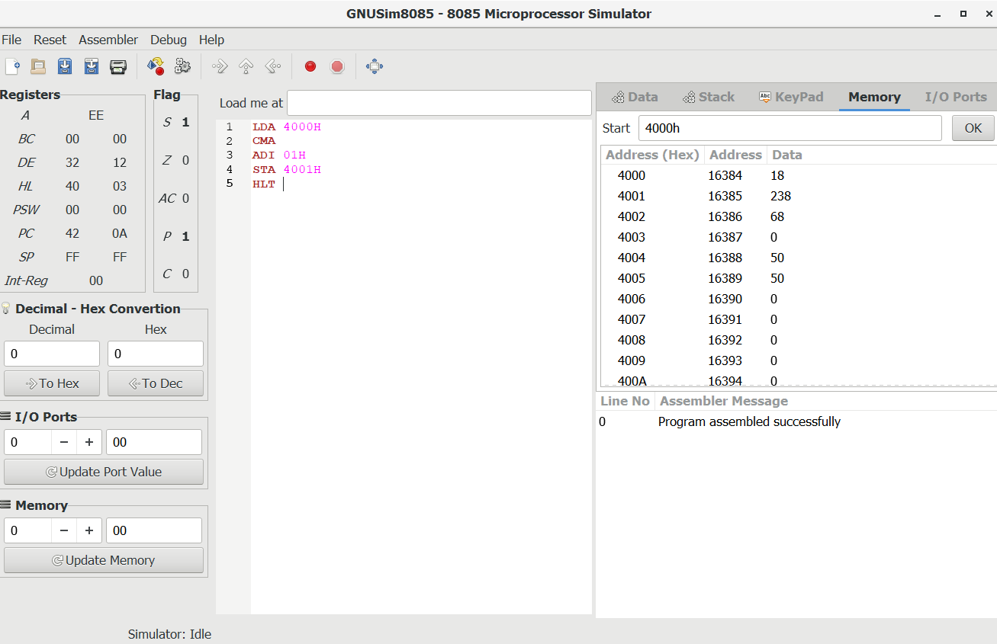

9-> Subtract the 16-bit number in memory locations 4002H and 4003H from the 16-bit number in memory locations 4000H and 4001H. The most significant eight bits of the two numbers are in memory locations 4001H and 4003H. Store the result in memory locations 4004H and 4005H with the most significant byte in memory location 4005H.

Code:-

LHLD 4000H ;GET FIRST 16 BIT NUMBER

XCHG ;SAVE FIRST 16 BIT NUMBER IN DE

LHLD 4002H ;GET SECOND 16 BIT NUMBER IN HL

MOV A,E ;GET LOWER BYTE OF FIRST NUMBER

SUB L ;SUBSTRACTE LOWER BYTE OF SECOND NUMBER

MOV L,A ;STORE RESUKT IN L REGISTER

MOV A,D ;GET HIGHER BYTE OF FIRST NUMBER

SBB H ;SUBSTRACTE HIGHER BYTE OF SECOND NUMBER

MOV H,A ;STORE RESULT IN HL

SHLD 4004H ;STORE 16 BIT RESULT IN MEMORY LOCATION 4004H

HLT

Output:-

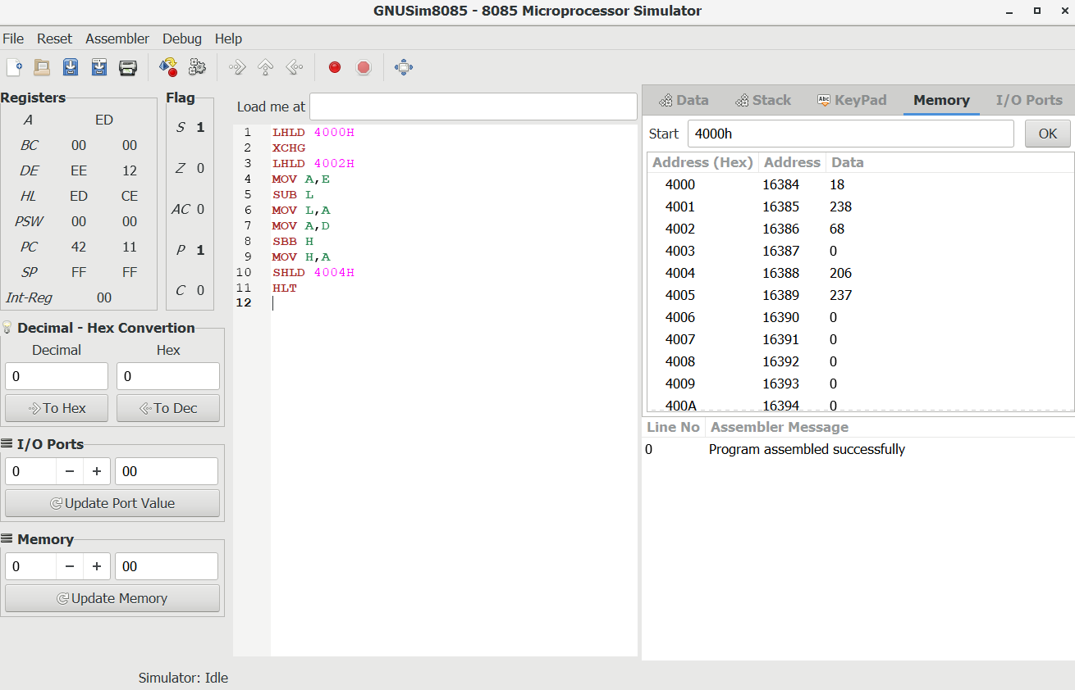

10-> Write a program using the ADI instruction to add the two hexadecimal numbers 3AH and 48H and store the result in memory location 2100H.

Code:-

MVI A,3AH

ADI 48H

STA 2100H

HLT

Output:-

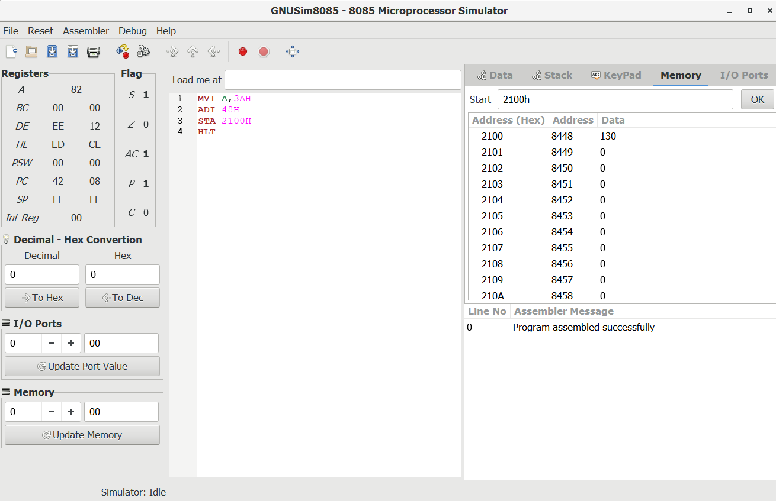

11-> Write an assembly language program that AND, OR and XOR together the contents of register B, C and E and place the result into memory location 3000H, 3001H and 3002H.

Code:-

MVI B,12H

MVI C,51H

MVI D,26H

MOV A,B

ANA C

ANA D

STA 3000H

MOV A,B

ORA C

ORA D

STA 3001H

MOV A,B

XRA C

XRA D

STA 3002H

HLT

Output:-

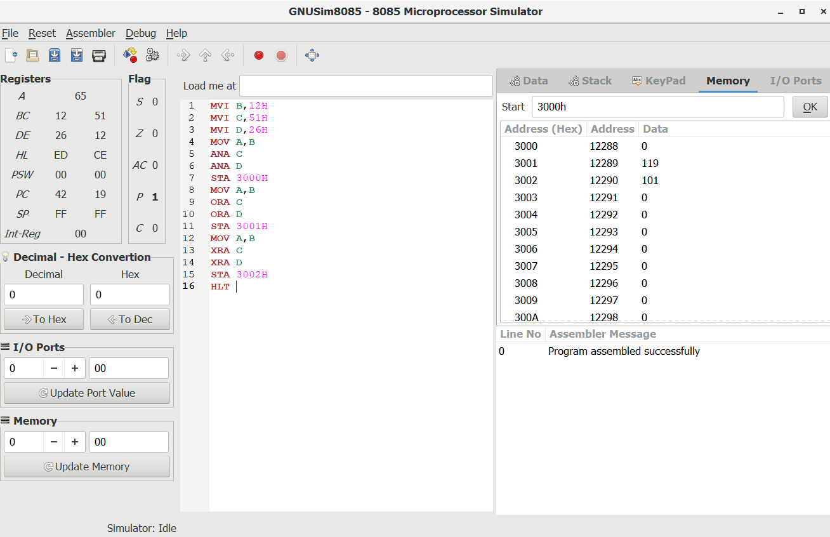

12-> Program to Find 1’s Complement of 16-bit Number.

Code:-

MVI A,1DH

mov L,A

MVI A,14H

mov H,A

SHLD 2000H

LHLD 2000H ;load into HL Pair

MOV A, L ;Load L into accumulator

CMA ;Complement

MOV L, A ;store in L

MOV A, H ;Load H into accumulator

CMA ;Complement

MOV H, A ;store in H

SHLD 2002H ;Store the 1's complemented result

HLT

Output:-

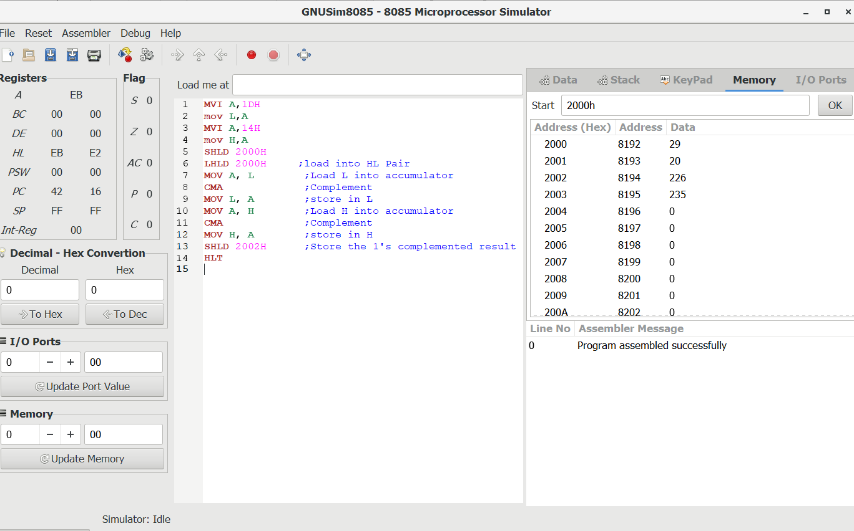

13-> Program to Find 2’s Complement of 16-bit Number.

Code:-

MVI A,2AH

mov L,A

MVI A,5BH

mov H,A

SHLD 2000H

LHLD 2000H ;load into HL Pair

MOV A, L ;Load L into accumulator

CMA ;Complement

MOV L, A ;store in L

MOV A, H ;Load H into accumulator

CMA ;Complement

MOV H, A ;store in H

INX H ;Increment register Pair by 1

SHLD 2002H ;Store the 2's complemented result

HLT

Output:-

